Proposal for solar street light project

1. Title :

Developmental programme of village Nuadihi under Renewable energy Sources by solar street lighting project .

2. Name and address of the organization :
Council for Socio Economic Benevolent Action / SEBA
At- Walliganj, Po- Bhanjpur, Dist- Mayurbhanj,
Orissa, INDIA, Pin - 757002.
Phone. 09437086933. E-mail : seba_orissa@sify.com .

3. Project objective :

The primary project objective is to enlighten the area by removing darkness beside the followings .

➢ Social security .

➢ Productive utilization of evening hours of the villagers by doing leaf plate
or Sabai rope making .

➢ Spreading Education and Literacy .

4. Target Area :

The target area village Nuadihi is situated at the base of Similipal forest of Hatikote GP in Mayurbhanj district , which is around 10 km from district head quarter Baripada . The village consist of ninty six families with total population of six hundred eighteen numbers. Due to hilly terrain the inhabitant don’t have sufficient agricultural land, Hence they have to depend upon alternative livelihood such as Sabai rope making , Leaf plate making etc, Some of them even work as daily laborer in the nearest town . It is unbelievable that the villagers have yet to see electric light in this twenty first century . The whole village became dark after evening . During this hour snake bite is inevitable as the surrounding reserve forest is largely inhabited by various poisonous snakes . So this Renewable Energy proposal for installation of eight number of solar street lights which switch on automatically at sunset and switch off automatically at sunrise will help the villagers to utilize their evening hours in some productive manner beside giving security from theft and from nocturnal animals . The students will also benefited from this programme .

Continued … p2

// 2 //

5. Project component :

The Project component consists of followings-

➢ Formation of village Committee for decision making and maintenance
of assets .

➢ Site identification for establishment of solar light units .

➢ Post project follow up .

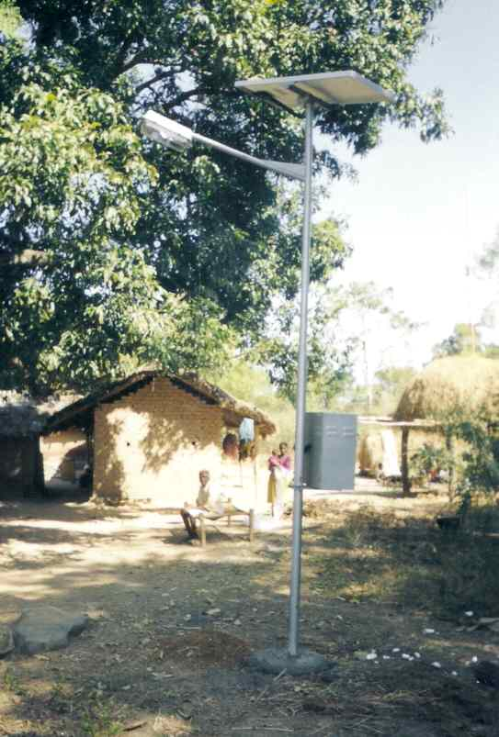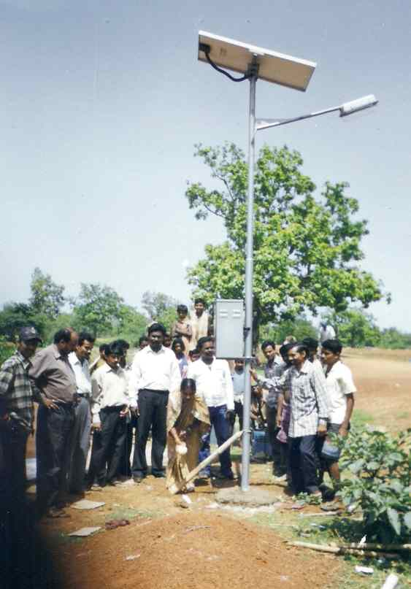
Solar cell Street light units installed in village Dhabani

6. Expected output :
(papers/ reports/ workshops/ on-field outcomes)

The village Nuadihi is situated at the base of Similipal forest, and surrounded by reserve forest. Although the village is at a distance of 10 km from district head quarter Baripada but yet to see electric light . The village consist of ninety six families with around eighty number of school going children, who cant continue their study up to higher secondary level due to non availability of basic facilities . Further due to hilly terrain the inhabitant don’t have sufficient agricultural land to cultivate, Hence they have to depend upon alternative livelihood such as Sabai rope making , Leaf plate making etc, Some of them even work as daily laborer

Continued … p3

// 3 //

in the nearest town. The whole village became dark after evening, during
this hour snake bite is inevitable as the surrounding reserve forest is largely inhabited by various poisonous snakes . So this Renewable Energy proposal for installation of eight number of solar street lights which switch on and switch off automatically at sunset and sunrise will help the villagers to utilize their evening hours in some productive manner beside giving security from theft and from nocturnal animals . The students will also benefited from this programme for continuing their study as it will be placed adjacent to group of houses.

7. Budget :

Sr. Project Unit cost Quantity/ Total
No Component in Rs Numbers in Rs

i) Solar Street light system 28,000/- 30 nos 8,40,000/-

ii) Installation, Commissioning 4,000/- 30 nos 1,20,000/-
& Transportation .

iii) Organisational arrangements 30,000/- LS 30,000/-
Logistic support etc

TOTAL Rs 9,90,000/-

Total assistance required is Rupees nine lakh ninety thousand only,
Or, $ 20,450 (twenty thousand four hundred fifty US Dollar) only .

8. Implementation schedule :

The initial project period will be of four month duration , with a follow up period of one year. During 1st month One village committee will be formed , they will select suitable places for installation of Solar light points . In 2nd month order will be placed for installation of solar light systems. During 2nd & 3rd month installation of solar light systems will continue. In 4th month some selected members of village committee will be trained by the supplying agency regarding maintenance of solar light systems. The village committee will be encouraged for more such community action in future .

Continued … p4

// 4 //

We have provided all the relevant information in the above pages. But if any more information or documents such as copy of Societies registration certificate, Audit report, Annual report, Income Tax registration certificate, FCRA Rgn etc required we are always ready to provide them .

Sandhyarani Dash
Secretary, SEBA.
21st Sept 2011.



